Mete A. Sözen: A Collection of Personal Remembrances

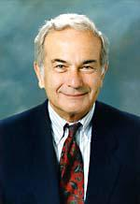

Mete A. Sözen, Karl H. Kettelhut Distinguished Professor, Emeritus of Civil Engineering, Purdue University died unexpectedly on April 5, 2018, just a few weeks before what would have been his 88th birthday. Mete was in London, England, with his wife Joan visiting their daughter Ayshe and two grandsons when he fell peacefully to sleep. For all of us who knew Mete, this marked the end of an era. Few people have guided and nurtured a field the way Mete led earthquake and structural engineering related to reinforced concrete systems over a period spanning six decades. He had a profound effect on many people and will long be remembered fondly by those who came into contact with him during his career. His impact was so compelling that he had earned the admiration of many generations of students, friends and colleagues and fellow engineers. This article records some of our thoughts about this remarkable man.

An only child, Mete was born, according to official birth registry bureau records, on May 22, 1930 in Istanbul Turkey. His family traces its roots to western Georgia from which they had been driven westward during nineteenth century’s numerous armed conflicts in the area, settling first in the city of Ordu on the Black Sea coast and finally in Istanbul. He attended elite primary and secondary schools before enrolling in Robert College, an independent school established in 1863 for the purpose of “giving to its students a thorough education equal in all respects to that obtained at a first-class American college and based upon the same general principles.” Graduating in 1951, he was granted entry into the University of Illinois in Urbana-Champaign where he went on to receive his M.S. and Ph.D. degrees. After earning his M.S. degree in 1952, he worked as a structural designer with Kaiser Engineers (Oakland, CA) and Hardesty and Hanover (New York, NY). His doctoral dissertation completed in 1957 and supervised by Chester P. Siess dealt with the shear strength of prestressed concrete beams that were then being used with increasing frequency in highway bridge construction in the US. Offered a faculty position by department chair Nathan M. Newmark that same year he joined the Department of Civil Engineering as a young assistant professor. For the next 36 years at Illinois he would pursue a career for development of professional design codes for reinforced and prestressed concrete structures, and for earthquake-resistant design of reinforced concrete structures.

With a fine tradition of reinforced concrete research established during the first half of the twentieth century by experimenters Arthur N. Talbot, Duff A. Abrams and Frank E. Richart and professors like Harold M. Westergaard and Hardy Cross who provided the analytical prowess, the University of Illinois had become the leading source of expertise in U.S. academia on structural engineering with emphasis on reinforced concrete, whether of a seismic nature or not. This occurred not only because of Newmark and his strong faculty, but because the department had a major testing facility. Later, by mid 20th century, Newmark would attract additional attention and talent to Urbana as he dealt first with design against blast effects brought about by the Cold War, and then seismic effects to keep abreast of the needs in nuclear power. Mete began his career at Urbana in such an environment.

The influential book published by PCA that Newmark co-authored, “Design of Multistory Reinforced Concrete Buildings for Earthquake Motions” (Blume et al. 1961) has long been recognized as an enduring source of information for the design of reinforced concrete building systems. Mete was already an expert on reinforced concrete construction as a faculty member, so he played a large role in writing that book. The concepts of energy dissipation in cyclically loaded reinforced concrete assemblies, ductility, and strength or stiffness decay that now are routinely included in code provisions in implicit form, and make up a central part of earthquake engineering curricula in schools were not quite so routine when the book was written fifty-seven years ago. It served to inspire experimental research during the following few decades. In retrospect, the book was in defense of reinforced concrete buildings that had received a bad review (in an AISC reconnaissance report) after their horrible performance during the Agadir earthquake in Morocco in 1960. Despite its moderate magnitude, the earthquake had killed one-third of the population of the coastal resort city on account of the prevailing construction techniques that did not consider at all the effects of ground motions. The PCA book of a year later by Blume, Newmark and Corning showed that, with proper detailing and adherence to good construction practices, reinforced concrete building systems could be made as safe as steel framed buildings. This was the first publication to address the principles of capacity-based seismic design (a term coined later by others) and the need for ductility and detailing in earthquake-resistant reinforced concrete structures.

The 1960s witnessed three additional major earthquakes that in quick succession occurred in Skopje, Macedonia (1963), Anchorage, Alaska (1964) and Caracas, Venezuela (1967). Mete visited all three sites, and produced carefully written survey reports on the causes of the poor performance of reinforced concrete buildings. Each of his field reports is a delightful technical account that displays his intuitive grasp for what had caused the damage that his photos displayed. Something seemed to be wrong with the way such buildings were designed in all of these disparate locations because traditional code requirements then in effect simply fell short of providing the necessary attributes for protecting the public from the seismic peril. The structural engineering community needed to develop a new set of design guidelines driven first by field evidence, and then distilled through lab experiments including tests conducted on earthquake simulators where possible, eventually to be refined in the form of code requirements.

Shake tables did exist in several countries prior to the 1960s, but these were suitable mostly for seismometric instrument calibrations and observations, or modest model tests that did not lead to useful structural engineering interpretations adaptable for design. So with NSF support, Mete embarked on a program for building a single-axis shaking table at the University of Illinois, Urbana. The 3.6-m square table had a five-ton payload capacity and was built by an aerospace company in California. It was the first of its kind, and was delivered in late 1967, becoming operational in 1968. Although equipped with limited stroke and velocity capabilities compared with current simulators, that platform was to serve as the prime research tool for over twenty graduate students for the next 25 years because it could provide the possibility to reproduce a ground motion with scaled time and acceleration that had not been available earlier for structural testing. In his own opinion, the most important impact of their work was the “paradigm shift” (a cliché that he used with sarcasm) in design for earthquake resistance from force to displacement. In retrospect, it should have been evident as soon as Takeda finished his work or when Shibata-Umemura at Tokyo University noted that a reduction in strength was not necessarily accompanied by an increase in response displacement, but it took many more years and tests before the obvious became obvious.
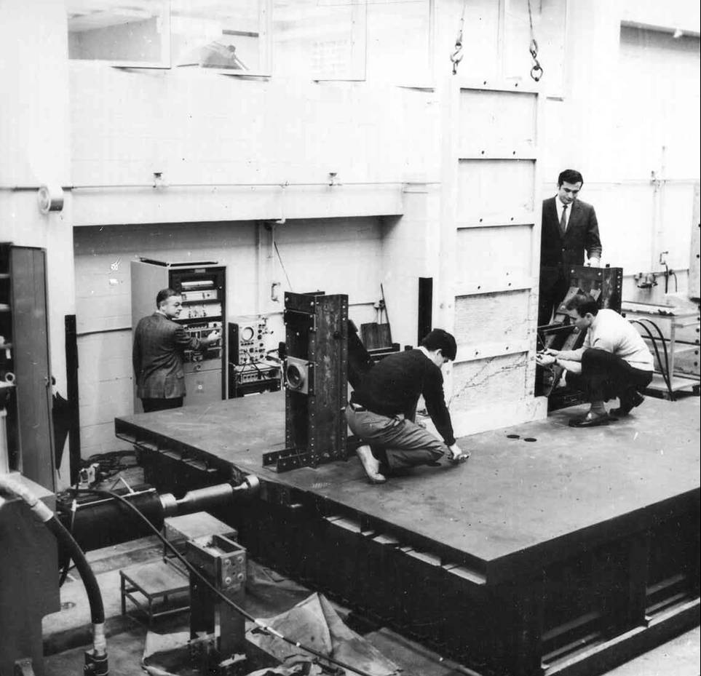
The University of Illinois Earthquake Simulator, 1968
Clockwise from left: N. Nielsen, M. Sözen, P. Gülkan and S. Otani

Mete’s initial research interest had focused on prestressed concrete. For the 1963 Building Code of the Americal Concrete Institute, he formulated the basic concepts that are still used for determining the shear strength of prestressed concrete elements. His studies of bond between concrete and strand helped define the mechanism of bond for high-strength strand.

In reinforced concrete he was known for his experimental and analytical investigations toward methods for the analysis and design of slabs. His work was instrumental in providing a firm foundation for the theory of plasticity in reinforced concrete subjected to multi-axial forces. He served for many years on the Building Code Committee 318 of the American Concrete Institute, and was the chair of 318 Subcommittee C “Safety, Serviceability and Analysis" from 1974 through 1995. He served in the Subcommittee H “Seismic Provisions” that in 1971 prepared the first set of specifications for earthquake resistance, now Chapter 18 of the Code. He served as well in many technical committees of ACI, ASCE, European Concrete Committee, Prestressed Concrete Institute and the Earthquake Engineering Research Institute. Other professional services included chairmanship of the US National Committee on Natural Disasters. For research related to earthquake issues he served on the Joint US-People’s Republic of China Committee and the US-Japan Committees, and on the Illinois Governor’s Earthquake Preparedness Task Force. He was a member of the US Veterans Administration Advisory Committee on Structural Safety. He was a consultant to the Department of State on seismic matters, and worked with the US Bureau of Reclamation on seismic response of dams. Other consultancies included the US Advisory Committee on Reactor Safeguards, US Nuclear Regulatory Commission, Los Alamos Laboratories, US Army Engineers Waterways Experiment Station, the Electric Power Research Institute, Sandia National Laboratories, Bechtel, Erico, Westinghouse and Wiss, Janney and Elstner.

The February 1971 San Fernando earthquake served as another catalyst for questioning the core wisdom of the SEAOC Blue Book requirements that UBC had adopted for seismic design. Alarmed by the abject collapse of several buildings in one of their medical care facilities in Sylmar, the Veterans Administration invited a team led by Mete, Roy Johnston, an LA consulting engineer, and Bruce Bolt from the University of California, Berkeley to formulate earthquake resistant design requirements for VA health care facilities. This mission was accomplished with the completion in 1974 of Handbook H-8-08 Earthquake Resistant Design Requirements for VA Hospital Facilities that would serve also as a retrofit guide for existing facilities. This brief document is notable not only for its no-frills and pithy requirements for design and assessment but also because it represented a fundamental change of course for formulating the base shear force. Rather than stating reduced zone-dependent coefficients for the total force at the base, it listed linear force reduction factors for different classes of building types. Thus it presaged the ATC 3-06 guidelines of 1978 that have gone through much revision since then before becoming the accepted canon for the equivalent lateral force procedure in ASCE 7. The transformation of the substitute damping and then the substitute structure concepts into what he called the method of “Velocity of Displacement” is a brilliant testimony of his grasp of the correct (or, if not absolutely correct, realistic) path for earthquake structural engineering. The velocity of displacement procedure demonstrates that the driving parameters in the estimation of drift demand are initial period and peak ground velocity, PGV. Nearly seventy years earlier Westergaard had also pointed out that PGV was the key quantity for drift. Mete often cited this work with appreciation.

With mounting evidence from the shake table tests at Illinois he developed the notion (which he jokingly called “naive”) that time was now ripe to enunciate the ultimate heterodoxy: reinforced concrete structures should be proportioned on the basis of drift and then checked for lateral strength rather than being proportioned for strength and then checked for drift. The seed for displacement-based seismic design was thus sown. Among his other major contributions, it is worth mentioning two additional ones: understanding of decay of shear resisting mechanisms in concrete members under displacement reversals and development of methods for rapid evaluation of vulnerability of structures during earthquakes.

He leveraged his work in earthquake engineering to address the blast-response of concrete structures. He played important roles in the ASCE teams that investigated the response of the Murrah Building in Oklahoma City in 1995 and the Pentagon on 9/11.

From 1993 until 2016 Mete Sözen taught at Purdue University as the Kettelhut Distinguished Professor of Structural Engineering. At Purdue, he pursued with the same vigor what he called his “work,” teaching and inspiring students, helping enhance structural testing facilities of the department and consulting on a broad range of topics. Besides his research contributions in the field of earthquake engineering, he had a profound influence on the education of generations of researchers during the nearly sixty years that his career spanned. His maxim was that simplicity was the ultimate sophistication. Many of his former students have held leading positions in the structural engineering field during the past several decades. A favorite anecdote of his was one where someone approached him after a lecture to commend him for continuing the family dedication to excellence because he had enjoyed reading papers written by his father in the 1950s. Mete said he was too embarrassed to admit that he was that father as well.

Honors, etc.

His peers honored Mete Sözen on many occasions during his career. The following text lists these and other achievements.

Honorary Memberships

U.S. National Academy of Engineering 1977
Royal Swedish Academy of Engineering Sciences 1980
American Society of Civil Engineers 1994
American Concrete Institute 1999
Architectural Institute of Japan 2010
International Association for Earthquake Engineering 2012

Honorary Degrees

Johann Pannonius University, Hungary 1998
Georgian Technical University, Tbilisi 1998
Bogazici University, Turkey 2004

Awards

A. Epstein Prize, University of Illinois 1961
Huber Civil Engineering Research Prize, American Society of Civil Engineers 1963
R. C. Reese Award, American Society of Civil Engineers 1970
Moisseiff Award, American Society of Civil Engineers 1972
Kelly Award, American Concrete Institute 1976
Delmar Bloem Award, American Concrete Institute 1985
D. C. Drucker Award, University of Illinois 1986
Howard Award, American Society of Civil Engineers 1987
Boase Award, Reinforced Concrete Research Council 1988
The Register – Witness of Excellence, El Instituto Mexicano del Cemento
y del Concreto 1989
Lindau Award, American Concrete Institute 1993
R. C. Reese Award, American Society of Civil Engineers 1994
Parlar Award for Science & Technology, Middle East Technical University 1995
Phil M. Ferguson Commemorative Lecturer, American Concrete Institute 1995
Kavanagh Lecture, Penn State University 1995
ASEE General Electric Senior Research Award 1997
Honorary Chapter Member, Chi Epsilon 1997
Meritorious Publication Award, Structural Engineers Association of Illinois 1997
Lifetime Achievement Award, Illinois Section Structural Group 1998
Outstanding Paper Award, ASCE Council on Forensic Engineering 1998
Distinguished Lecturer, Earthquake Engineering Research Institute 2002
Noel Nathan Memorial Lecturer, University of British Columbia 2002
John Parmer Award, Structural Engineers Association of Illinois 2003
FrankE.Richart Lectureship Award, University of Michigan 2005
Top US Seismic Structural Engineer 20th Century, Applied Technology Council
and Engineering News Record 2006
Hardy Cross Commemorative Lecturer, American Concrete Institute 2007
Wason Medal for Most Meritorious Paper, American Concrete Insitute 2008
Newmark Distinguished Lecture, CEE Structures, University of Illinois,
Urbana-Champaign 2008
George W. Housner Medal, Earthquake Engineering Institute 2011
Chester P. Siess Award for Excellence in Structural Research, American
Concrete Insitute 2016
Design Award, American Concrete Institute 2018

In Passing

Professor Sözen had an unmatched skill and instinctive ability to convey an idea or an impression in spoken or written form. This must have been the continuation of the tradition for creating permanently inspiring technical prose shaped by Hardy Cross and inherited through Nathan Newmark. Engineers need not ever write dull texts, he opined, just because they address cut-and-dry compositions where things are simply affirmed or denied. In the opening passage to one of his papers he wrote that a column in a modern high-rise reinforced concrete building was to a masonry pillar what a caryatid was to a Daliesque beauty. Not many of us will think of writing that in a technical paper.

His lectures were always a source of delight because of the uniquely attractive quality he was able to inject into whatever topic he happened to be discussing. He always brought the foundational research and researchers to the forefront in his lectures and speeches, without ever citing his own contributions. He shrank from accolades and praise of all kinds, dismissing them with a quick wave of the hand. He was a prodigious reader on a wide variety of non-technical subjects: biography, history, politics, music, art, architecture as well as fiction. He would insert a quote, draw a parallel, point to a nuance that would envelope the subject, embedding it in the audience’s subconscious memory permanently. He habitually challenged conventional wisdom, pointing out that all scientific progress had been achieved by the naive who were not encumbered by preconceptions. Karl Popper’s insistence that all scientific propositions should first be rigorously questioned before they are put to use for others found frequent echo in his advice. Nothing made him happier than to enjoy a good meal and good wine in the company of friends who were frequently his students. The circle tried to make sense of the world but always found the true solution in one another's company, surrounded by books, food, beauty and lively conversation. In their thirst for truth and understanding they learned something new every day. It will not be inaccurate to assume that everyone who ever was acquainted in some way with this tremendously talented and unique man will miss him very much. The list of hic doctoral students is reproduced here as an Appendix.

The middle initial in his name, “A.” stands for “Avni,” an Ottoman word that means “bringer of help” or “provider of divine relief.” Mete Avni Sözen was indeed a man who lived up to those qualities that his name brought upon him. His life’s pattern shows that he was always there to help gracefully anyone who needed it.

Mete Avni Sözen is survived by his wife Joan and family Timothy, Adria, Ayshe, and four grandchildren.

This account has been put together with contributions from the following individuals listed alphabetically:

R. Bates P. Jennings S. Pujol
J.A. Browning J. Jirsa R. Reitherman
M. Calvi M. Kreger A. Schultz
C. French J. Lefter J. Sözen
L. Garcia A. Lepage T. Sözen
P. Gülkan J.P. Moehle S.T. Wasti
A. Irfanoğlu S. Otani J. Wight
G. Parra-Montesinos S. Wood

During his career Mete A. Sözen had amassed a very large number of referenced documents, reports, videos, visual material and various other sources of knowledge. These useful items of his personal digital library are curated at:

datacenterhub.org/resources/14152#Mete%20Sozen's%20Digital%20Library.

APPENDIX: LIST OF STUDENTS WHO COMPLETED THEIR PH.D. DISSERTATIONS UNDER METE A. SÖZEN’S SUPERVISION

BRUCE, ROBERT NOLAN, JR.
An Experimental Study of the Action of Web Reinforcement in Prestressed Concrete Beams (1962)

GAMBLE, WILLIAM LEO
Measured and Theoretical Bending Moments in Reinforced Concrete Floor Slabs (1962)

GERGELY, PETER
The effect of Reinforcement on Anchorage Zone in Prestressed Concrete Members (1962)

JIRSA, JAMES OTIS
The Effects of Pattern Loadings on Reinforced Concrete Floor Slabs (1963)

ROY, HEDLEY EDMUND HERBERT
A Failure Theory for Concrete (1963)

VANDERBILT, MORTIMER DANIEL
Deflections of Reinforced Concrete Floor Slabs (1963)

MOORE, WALTER PARKER
An Analytical Study of the Effect of Web Reinforcement on the Strength of Reinforced Concrete Beams Subjected to Combined Flexure and Shear (1964)

LENSCHOW, ROLF JOHAN
A Yield Criteria for Reinforced Concrete under Biaxial Moments and Forces (1966)

WELSH, WILLIAM AUSTIN, JR.
Analysis and Control of Anchorage-Zone Cracking in Prestressed Concrete (1966)

CARDENAS-ENRIQUEZ, ALEX
Strength and Behavior of Isotropically and Nonisotropically Reinforced Slabs Subjected to Conbinations of Flexural and Torsional Moments (1968)

FEDORKIW, JAMES PAUL
Analysis of Reinforced Concrete Frames with Filler Walls (1968)

STOCKER, MANFRED FRANZ
A Hypothesis for the Nature of Bond between Strand and Concrete (1969)

CRISWELL, MARVIN EUGENE
Strength and Behavior of Reinforced Concrete Slab-Column Connections Subjected to Static and Dynamic Loading (1970)

FIORATO, ANTHONY EMIL
An Investigation of the Interaction of Reinforced Concrete Frames with Masonry Filler Walls (1971)

GÜLKAN, POLAT
Behavior and Energy Dissipation of Reinforced Concrete Frames Subjected to High Level Base Motions (1971)

KARLSSON, BENGT INGVAR
Shear Strength of End Slabs with and without Penetrations in Prestressed Concrete Reactor Vessels (1971)
IMBEAULT, FERNAND ADELARD
Bilinear and Degrading Bilinear Response of Multistory Frames (1972)

AKTAN, AHMET EMIN
Effects of Two-Dimensional Motion on a Reinforced Concrete Column (1973)

OTANI, SHUNSUKE
Behavior of Multistory Reinforced Concrete Frames during Earthquakes (1973)

STORM, JOHN HENRY
A Finite Element Model to Simulate the Non-Linear Response of Reinforced Concrete Frames with Masonry Filler Walls (1973)

WIGHT, JAMES KENNETH
Shear Strength Decay in Reinforced Concrete Columns Subjected to Large Deflections (1973)

HSU, LUNG WEN
Behavior of Multistory Reinforced Concrete Walls during Earthquakes (1974)

ARISTAZABAL-OCHOA, JOSE DARIO
Behavior of Ten-story Reinforced Concrete Walls Subjected to Earthquake Motions (1977)

LYBAS, JOHN MICHAEL
Effect of Beam Strength and Stiffness on Dynamic Behavior of Reinforced Concrete Coupled Walls (1977)

ABRAMS, DANIEL PAUL
Experimental Study of Frame-Wall Interaction in Reinforced Concrete Structures Subjected to Strong Earthquake Motions (1979)

CECEN, HALUK
Response of Ten Story Reinforced Concrete Model Frames to Simulated Earthquakes (1979)

SAIIDI MOVAHHED, MEHDI
Simple and Complex Models for Nonlinear Seismic Response of Reinforced Concrete Structures (1979)

MOEHLE, JACK PETER
Experiment to Study Earthquake Response of R/C Structures with Stiffness Interruptions (1980)

MORRISON, DENBY GREY
Response of Reinforced Concrete Plate-Column Connections to Dynamic and Static Horizontal Loads (1981)

ALGAN, BEKIR BULENT
Drift Damage Considerations in Earthquake-Resistant Design of Reinforced Concrete Buildings (1982)

HOEDAJANTO, DRADJAT
A Model to Simulate Lateral-Force Response of Reinforced Concrete Structures with Cylindrical and Box Sections (1983)

KREGER, MICHAEL EUGENE
An Experimental/Analytical Study of the Dynamic Response of Staggered Structural Wall Systems, (1983)
FRENCH, CATHERINE ELLEN WOLFGRAM
Experimental Modeling and Analysis of Three One-Tenth Scale Reinforced Concrete Frame-Wall Structures (1984)

BARIOLA BERNALES, JUAN J.
Dynamic Stability of Adobe Walls (1986)

SCHULTZ, ARTURO ERNEST
An Experimental and Analytical Study of the Earthquake Response of R/C Frames with Yielding Columns (1986)

WOOD, SHARON LEE
Experiments to Study the Earthquake Response of Reinforced Concrete Frames with Setbacks (1986)

LOPEZ, RICARDO RAFAEL
A Numerical Model for Nonlinear Response of R/C Frame-wall Structures (1988)

STARK, ROBERTO
Evaluation of Strength, Stiffness and Ductility Requirements of Reinforced Concrete Structures Using Data from Chile (1985) and Michoacan (1985) Earthquakes (1988)

BONACCI, JOHN FRANCIS
Experiments to Study Seismic Drift of Reinforced Concrete Structures (1989)

EBERHARD, MARC OLIVIER
Experiments and Analyses to Study the Seismic Response of Reinforced Concrete Frame-Wall Structures with Yielding Columns (1989)

WALTHER, HOWARD PHILLIP
Evaluation of Behavior and Radial Shear Strength of a Reinforced Concrete Containment Structure (1990)

DE LA COLINA, JAIME
A Hysteresis Model for Reinforced Concrete Space Frame Structures (1993)

DRAGOVICH, JEFFREY JOHN
An Experimental Study of Torsional Response of Reinforced Concrete Structures to Earthquake Excitation (1996)

LEPAGE, ANDRES
A Method for Drift Control in Earthquake-Resistant Design for RC Building Structures (1997)

BROWNING, JOANN P.
Proportioning of earthquake -resistant reinforced concrete building structures (1998)

DÖNMEZ, CEMALETTIN
A Numerical Model to Simulate the Behavior of Reinforced Concrete Members Subjected to Biaxial Earthquake Excitation (1998)

MATAMOROS, ADOLFO BENJAMIN
Study of Drift Limits for High Strength Concrete Columns (1999)

KORU, BURAK Z.
Seismic Vulnerability Assessment of Low-Rise Reinforced Concrete Buildings (2002)

PUJOL, SANTIAGO
Drift Capacity of Reinforced Concrete Columns Subjected to Displacement Reversals (2002)

OZTÜRK, BAKI M.
Seismic Drift Response of Building Structures in Seismically Active and Near -Fault Regions (2003)

GÜR, TÜREL
Earthquake Effects on Articulated Structures Located in Fault Rupture Zones (2004)

SMITH, JHON PAUL
Wall-Frame Structures with Vulnerable Foundations (2004)

AKIN, LILI A.
Behavior of Reinforced Concrete Frames with Masonry Infills in Seismic Regions (2006)

MIAMIS, KONSTANTINOS
A Study of the Effect of Combined Impact and Fire on Structural Steel Framing (2007)

FICK, DAMON R.
Experimental Investigation of a Full-Scale Flat-Plate Reinforced Concrete Structure Subjected to Cyclic Lateral Loading in the Inelastic Range of Response (2008)

BRACHMANN, INGO
On Efficient Modeling of High-Velocity Fluid Solid Impact (2008)

